**Ajax:**

AJAX allows web pages to be updated asynchronously by exchanging data with a web server behind the scenes.

This means that it is possible to update parts of a web page, without reloading the whole page.

AJAX allows you to send only important information to the server not the entire page.

So only valuable data from the client side is routed to the server side.

It makes your application interactive and faster.

**How AJAX Works**

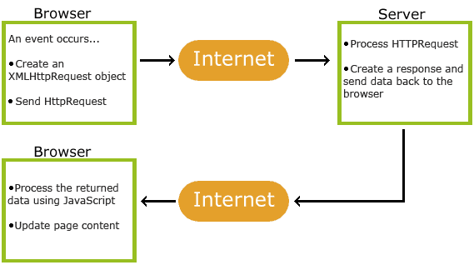

1. An event occurs in a web page (the page is loaded, a button is clicked)

2. An XMLHttpRequestobject is created by JavaScript

3. The XMLHttpRequestobject sends a request to a web server

4. The server processes the request

5. The server sends a response back to the web page

6. The response is read by JavaScript

7. Proper action (like page update) is performed by JavaScript

# **Synchronous vs Asynchronous**

## Synchronous

A synchronous request blocks the client until operation completes i.e. browser is unresponsive. In such case, javascript engine of the browser is blocked.

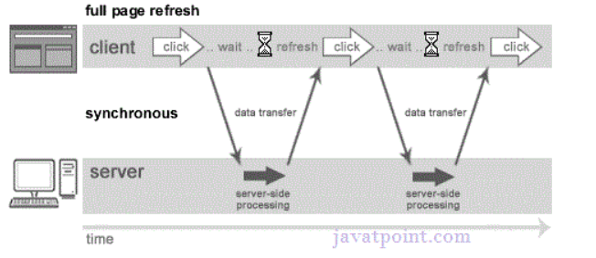

## Asynchronous

An asynchronous request doesn’t block the client i.e. browser is responsive. At that time, user can perform another operations also. In such case, javascript engine of the browser is not blocked.

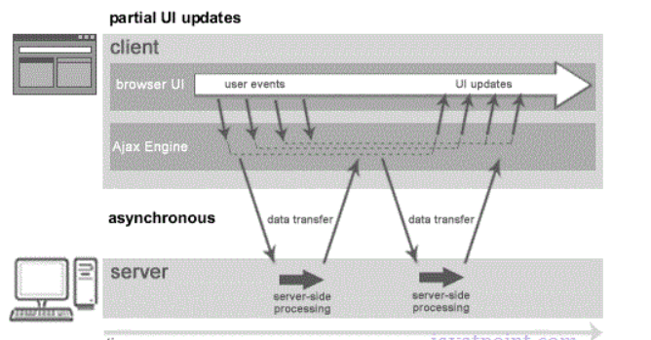

# **AJAX Technologies**

As describe earlier, ajax is not a technology but group of inter-related technologies. AJAX technologies includes:

* HTML and CSS
* DOM
* XML or JSON
* XMLHttpRequest
* JavaScript